**Investment Summary: Changchun High-Tech Industry Group Co Ltd (000661.SZ)**

As of: 5 September 2025  
Stock Price (previous close): 104.98 CNY  
Market Cap: Approx. 20 billion CNY  
Industry: Pharmaceutical & High-Tech Manufacturing  
Recommended Action: Hold

**Business Overview**

Changchun High-Tech Industry Group focuses on manufacturing pharmaceuticals, biologics, and high-tech medical products, with extensive involvement in growth hormones and reproductive health products. FY 2024 revenue was approximately $1.87 billion USD (≈13.5 billion CNY), down 8.76% from 2023 due to market pressures and operational challenges. The firm holds an 8.5% market share in China's high-tech healthcare segment with over 400 patents, underpinning its innovation capability. Its products target hospitals, clinics, and pharmaceutical distributors, catering to a domestic market heavy reliance (~90%) with industry trust and brand equity valued at about ¥32.7 billion. Key strengths include R&D capabilities and brand reputation; challenges involve increased operational costs and regulatory pressures.

**Business Performance**

* Revenue declined 0.54% in H1 2025 to 6.6 billion RMB, net profit down 42.85% YoY due to higher costs and pricing pressures.
* Revenue showed a downward trend in 2024 with a 7.55% decline from 2023, and net income dropped by 43%.
* Operating cash flow meets capital expenditure requirements but profit margin compression remains a concern.
* Market share held steady but sales growth slowed amidst competitive pressures.

**Industry Context**

* Pharmaceuticals in China grow at about 6-7% annually with innovation and regulatory compliance as key drivers.
* The industry is marked by intense domestic and international competition and evolving regulatory landscape.
* Changchun High-Tech’s reliance on domestic sales increases exposure to local policy shifts.
* Its average P/E ratio is lower (~10.8x), compared to sector peers, reflecting market concerns about recent profit declines.

**Financial Stability and Debt Levels**

The company has a moderate liquidity position with a current ratio above 1, but shrinking profitability impacts free cash flow. Debt levels are manageable but operational cost rises and regulatory delays pose risk for cash flow stability. Return on equity is modest at 8.6%, indicating efficient but pressured capital use. Interest coverage remains sufficient but requires close monitoring.

**Key Financials and Valuation**

* FY 2024 revenue: $1.87 billion USD (~13.5 billion CNY), -8.76% YoY.
* Net income: declining sharply (~42.85% drop H1 2025), net margin under pressure at 8%.
* P/E at 10.8x, below market average, indicating possible undervaluation amidst quality concerns.
* DCF valuation at 90.9 CNY vs stock price 104.98 CNY suggests limited upside (-13.4%).

**Big Trends and Events**

* Regulatory scrutiny and pricing reforms in China’s healthcare sector affecting margins.
* Overseas expansions planned, particularly into European markets with hormone products.
* Increasing raw material and labor costs erode profitability.
* Limited adoption of digital transformation risking competitive edge against industry leaders.

**Customer Segments and Demand Trends**

* Top customers are domestic hospitals, clinics, and pharmaceutical distributors.
* Projected revenue growth of around 15% over the next five years with innovation pipeline expansion.
* Demand shifts toward biopharmaceuticals and specialized health products are favorable trends.

**Competitive Landscape**

* Faces stiff competition from larger pharmaceutical groups like Fosun Pharma.
* Sustainable advantage via patent portfolio, brand recognition, and focused R&D.
* Key battlefront: innovation-driven product development and international market penetration.

**Risks and Anomalies**

* Revenue and net income decline in recent reports concerns investors.
* Regulatory environment unpredictability could delay product launches and approvals.
* High operational expenses and limited digitalization relative to peers are challenges.

**Forecast and Outlook**

* Management targets annual revenue growth near 15% driven by pipeline products and exports.
* Profitability improvement depends on cost control and successful new product adoption.
* Stock price may exhibit volatility due to earnings uncertainties.

**Leading Investment Firms and Views**

* Mixed analyst sentiment with cautious optimism; some recommend Hold given current valuation and profit pressures.
* Institutional ownership growing, indicating confidence in medium-term recovery.

**Recommended Action: Hold**

Pros:

* Strong brand, patent portfolio, and innovation pipeline position it well long-term.
* Moderate valuation and growing institutional interest support valuation base.

Cons:

* Recent earnings decline and revenue pressure.
* Regulatory and operational challenges.
* Need for accelerated cost management and digital transformation.

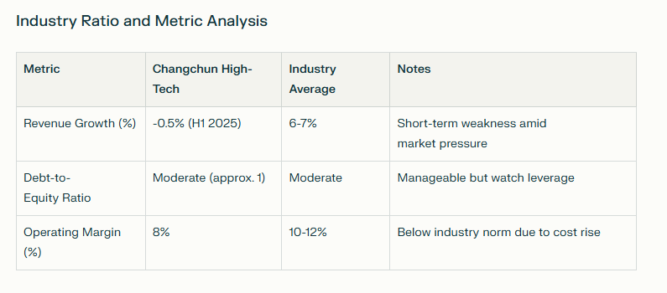

**Key Takeaways**

Changchun High-Tech Industry Group is a well-established pharmaceutical entity with solid R&D and a strong brand. However, recent financial results reflect near-term profit pressures from regulatory and operational costs. The Hold rating acknowledges its potential through pipeline expansion and market demand while cautioning on earnings volatility and necessary modernization investments.

**Sources**

* [Changchun High-Tech Industry Financials - CompaniesMarketCap](https://companiesmarketcap.com/changchun-high-tech-industry/revenue/)
* [DCF Valuation - ValueInvesting.io](https://valueinvesting.io/000661.SZ/valuation/dcf-growth-exit-5y)
* [VRIO Analysis - dcfmodeling.com](https://dcfmodeling.com/products/000661sz-vrio-analysis)
* [SWOT Analysis - dcfmodeling.com](https://dcfmodeling.com/products/000661sz-swot-analysis)
* [2025 Half Year Reports and News - Gelonghui, Futunn](https://www.futunn.com/en/stock/000661-SZ)
* [Yahoo Finance - Changchun High-Tech Industry](https://sg.finance.yahoo.com/quote/000661.SZ/key-statistics/)